**PJ 1 Report My Name: Francisco Valadez**

**A. The following is my Python source program:**

**// Please copy your source program into here from your Visual Studio IDE.**

**// Your code here must be in color.**

# Author: Francisco Valadez

# Date: 1/5/2020

# Purpose: CS119-PJ1: To play an adding-three-number game and earn/lose points for each win/lose. (PJ 1)

def testAdd(s1, s2, s3) : # define function testAdd, 3 parameters from caller

points = 10 # 10 points for each game

sum = int(input("Please enter the sum of these 3 numbers: " ) ) # get 3 numbers from the user

if sum == ( int(s1)+int(s2)+int(s3) ) : # is sum really correct? must use int() to convert str to integer

print("Congratulations! You are right! You earn " + str(points) + " points now." )

list[0] += points # add points to total for win, list[0] is a global variable

# print("Therefore, you have " + str(list[0]) + " points in your account!" )

else : # incorrect answer from the user

print("Sorry, it is not correct! You lose " + str(points) + " points now." )

list[0] -= points # deduct points from total for loss, list[0] is a global variable

# print("Therefore, you have " + str(list[0]) + " points in your account!" )

# MAIN PROGRAM :

total_points = 0 # variable to track total number of points for the player

list = [total_points] # one-element list to make list[0] a global variable for all functions to update

print ("Welcome to the Super Numbering game of Francisco Valadez!!!") ##### must use your name

your_name = input("Please enter your full name: ")

print ( your_name + ": Thank you for playing this number game. You have " + str(list[0]) + " points to start. ")

while True: # keep running until the user says "no"

s1 = input("Enter first number: ") #string s1

s2 = input("Enter second number: ") #string s2

s3 = input("Enter third number: ") #string s3

print ("You just entered 3 numbers: ", s1, s2, s3) # show three numbers in strings

testAdd(s1, s2, s3) # calling function testAdd to check and give award or penalty

print("Now, you have " + str(list[0]) + " points in your account!" )

play_again = input("Would you like to continue this game? 'yes' or 'no': ") #get player's input for continuation

if play_again == "no" : # only "no" will stop this game

break # to leave this while loop and exit the game

print("Thank you for playing this wonderful game designed by Francisco Valadez!!!") #### must use your name

x = input("Press Ctrl+Alt+PrtScn to get a snapshot of this console, then ENTER to exit: ")

# End of MAIN PROGRAM

**B. The following is the console output of my 3 test runs:**

**// One way to copy the console output is to press Ctrl+Alt+PrtScn.**

**// Another way to copy is to use the snipping tool. To paste the image is to press Ctrl+v.**

**// Please make sure your console is long enough to show all your output lines to be captured.**

**// Please copy your console output and paste into here:**

**Test Case 1:**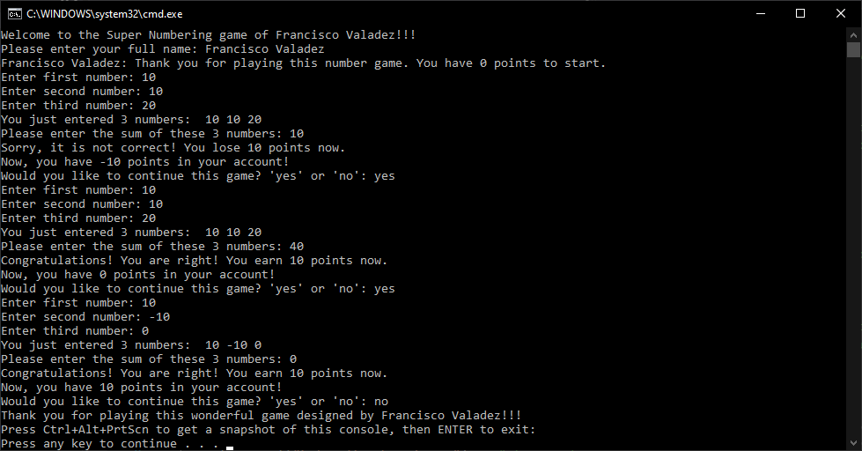

**Test Case 2:**

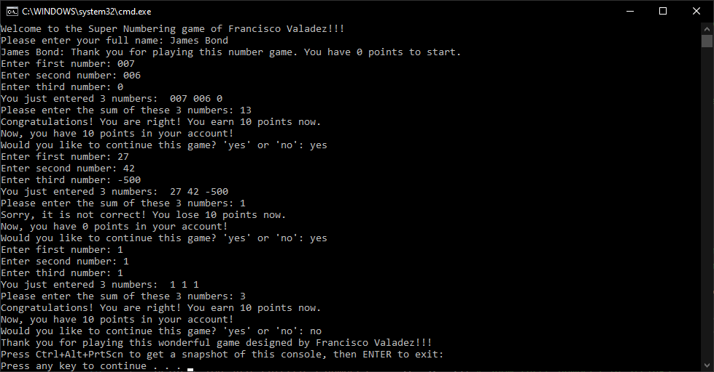

**Test Case 3:**

